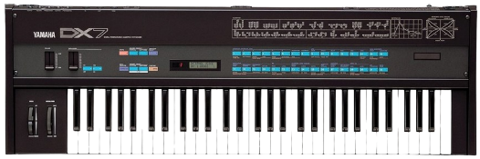
SONG: Carol of the Bells by Mannheim Steamroller

This synth-driven, high-energy song mixes modern electronic music production with progressive rock and classical-era music orchestration
0:00-0:22 JUST BELLS
0:22-0:43 SYNTH INTRO
0:16 – DX7 sound effect

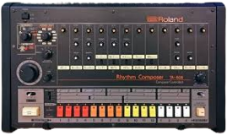
Two synth sounds enter: Synth Bell II, center panned, moderate volume, and Synth Lead, at a moderately loud volume with high resonance, panned slightly to the left; Synth Bell I continues to play

Song starts out with synth bells center-panned and playing at a steady, moderate volume


0:43-1:24 VERSE I
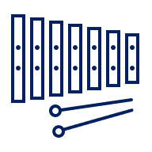
Synth bass enters (panned left), strings enter (panned left), drums enter (panned center), strings at a moderately low volume, drums and synth bass at a moderate volume, bells exit for a short time then return moderately loud

2:02-2:29 VOCAL BREAK
2:29-3:07 VERSE II
Vocoded (modified) vocals enter, fluctuating between left and right panning, moderate volume
Bass, drums, and bells enter with the same character as in the first verse, strings enter slightly quieter and less polyphonic (two pitches played at once rather than four) than before
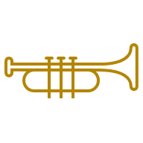
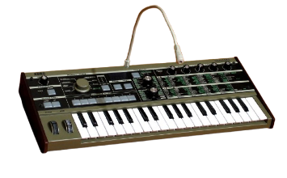



(still in Verse II)
All instruments exit in order at the end – synth lead, then bells, then drums, then (synth) bass

3:07-3:54 OUTRO
2:02 – Horns, synths exit

Two vocal synths, one with a “doo” verbalization and the other with a “bah” verbalization, are played back-to-back
1:24-2:02 BRIDGE
Bells exit, synth horns enter, moderate volume, centered panning, low frequencies slightly filtered

